**B. Studies and Results**

Project 6 aims to advance lead candidates developed by ASAP Project 5, and generate pre-clinical data to enable IND readiness for 2 broad-spectrum antiviral compounds by Year 5 (May 2027). By year 3 (May 2025), we aim to deliver early preclinical profiling for 1 broad-spectrum antiviral active against coronaviruses, including initial scale-up, process route development (PRD), *in vitro* preclinical profiling, ascending and multi-dose pharmacokinetic experiments and exploratory toxicology (non-GMP).

Project 6 is led by Drugs for Neglected Disease initiative (DNDi). Work on Project 6 started in November 2023. Over the last 5 months, DNDi put a team in place that will support pre-clinical development, and includes CMC, Toxicology, and DMPK consultants and internal specialists, as well as legal, finance and procurement support to advance the project at the required speed.

**Chemistry update:**

For the coronavirus broad-spectrum inhibitor (MERS/SARS-CoV-1/SARS-CoV-2-inhibitor), synthesis procurement for Project 6 started in November 2023, with initial procurement processes aimed to deliver three batches of following the criteria:

| Batch | Intended Use | Quantity | Purity criteria | Analytical criteria | Expected delivery date |
| --- | --- | --- | --- | --- | --- |
| A | Preclinical profiling | 20 g | >97% purity, > 95% ee (R,S) | 1H and 13C NMR, HRMS, LCMS | 4 months from contract start |
| B | Genotox profiling | 50 mg | ≥98% purity, with no impurity > 0.5%  > 99.0% ee (R,S) | 1H and 13C NMR, HRMS, LCMS | 4 months from contract start |
| C | DRF and Exploratory Toxicology | 500g | >97% purity, > 95% ee (R,S)  To be produced to solid form criteria provided by DNDi | 1H and 13C NMR, HRMS, LCMS  Relevant solid form analysis | 9 months from contract start |

As the final candidate to be declared in Project 5 is not yet defined (awaiting in vivo efficacy and second species PK), Procurement was split into 2 packages, starting with the delivery of **intermediate 13** (**Figure 1**), which will then be followed by four final steps of chemistry to reach the final candidate. These are likely to consist of the removal of the DMB, N-alkylation, activation of the OH; and displacement with an amine or conversion of the alcohol to an amine and alkylation (**Figure 2**).

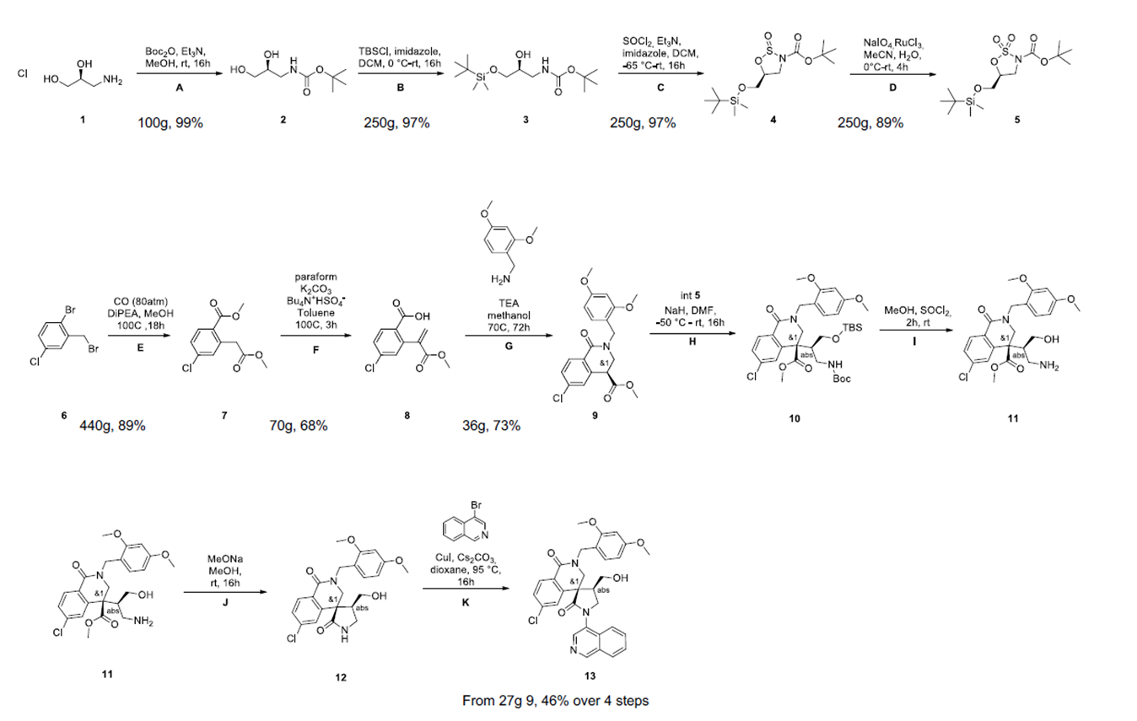

**Figure 1:** **Representative Synthesis of spiro intermediate 13, including yields of the current MedChem route.** This synthesis route is expected to be used for the delivery of the 20g batch, and will be optimized for the delivery of the 500g batch for ExploTox.

**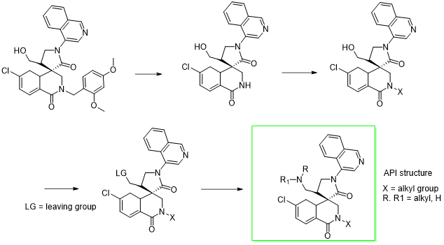  
Figure 2: Possible downstream chemistry to API – note X,R,R1 to be defined - used for the procurement process.** This route will be finalized in view of the lead candidate for preclinical development, but will likely include a [1] Removal of the DMB; [2] N-alkylation, [3] Activation of the OH; [4] displacement with an amine or conversion of the alcohol to an amine and alkylation.

DNDi launched an open bid for contract research organizations, and received 6 bids in response. Based on intellectual excellence and price competitiveness, two CROs were chosen. Work commenced in January 2024, and the CROs are aiming to deliver the initial batch (20 g) required for solid state work and accelerating dose experiments in two species (anticipated rat and dog) using the Medicinal Chemistry route. Further, 500g of material will be delivered at the end of Q2, which is required for ExploTox studies anticipated for Q3/4 2024. For this batch, chemistry teams at both locations are now optimizing the existing route, with a main focus of process route development. Similarly, a CRO to deliver solid state work has been selected (work anticipated to start in May 2024).

The current medicinal chemistry route shown above (Figure 1, 2) is designed to rapidly produce many variants around the central scaffold molecule 13 (Figure 1). While achieving this goal, the route is very inefficient to produce multi-gram/ sub kg quantities of any given API structure. Alongside typical reaction optimization, reduction in step count, the PRD work at CRO partners is targeted at a number of key deficiencies in the current route.

1) Use of protecting groups. Extensive protection and deprotection reactions are mass inefficient and result in extra steps. Work is underway to improve the synthesis by simplifying protecting group strategy by reducing the number of protecting groups and looking for conditions for conditions that result in ‘in situ’/single reagent removal of multiple protecting groups in a single step. Several successes have been identified and are now being developed.

2) Early introduction of one of the amine groups in the final API structure could replace introduction and removal of the dimethoxybenzyl amine protecting group. This has been demonstrated in principle, and investigations are underway to prove this change is compatible with downstream chemistry. To be deployed successfully, the structure of the candidate API needs to be confirmed.

3) Currently the diastereomer mix 13 has to be separated using supercritical fluid chromatography (SCFC) on a chiral stationary phase. While this is successful in isomer separation, it represents a pinch point in terms of excessive dilution and very high cost. A key goal has been to replace SCFC with a more efficient route to separate the diastereomer mix. It has now been demonstrated that a step change to unmask a basic amine can lead to a much more efficient diastereomeric salt resolution using a tartaric acid -based resolving agent. It has been shown that this pivotal advance is compatible with downstream chemistry and produces homochiral API molecules. This is currently being scaled up.

4) Any route separating diastereomers at a late stage with no opportunity to recycle the undesired isomer will be inherently inefficient and costly. Initial investigations have commenced to find a route that will avoid resolution and give high yields and purity of API. Some intriguing initial results have been obtained with model compounds and are being further explored.

**Update preclinical profiling and in vivo work:**

Project 6 supported the Lead Optimization team (P5) with planning and execution of the animal PK of the current lead compound (ASAP-0016506), with mouse oral PK studies performed at doses of 150, 300 and 450 mg/kg, with excellent exposures over free EC90 measured against MERS in cells (EC90 free 36nM), enabling planned in vivo efficacy experiments against MERS (commencing early April 2024). Additionally, we are evaluating exposures in a humanized mouse model, 8HUM mice (ongoing). Second species PK is planned for April 2024 and will enable refinement of the human dose prediction and completion of the data package required for selection of the preclinical candidate.

Further, P6 has been involved in compiling essential profiling experiments for the lead series, guided by results obtained through the COVID Moonshot program (funded through Wellcome Trust), including early determination of nuclear induction (cross-species data for PXR, AHR and CAR receptors).

**Update on other P6 activities:**

* Input into the pandemic preparedness strategy for small molecules led by the International Pandemic Preparedness Secretariat (IPPS) and WHO, with additional input from other global stakeholders
* Refinement of ASAP TPPs with a focus on Coronaviruses, Enteroviruses and Flaviviruses, in view of released APP TPPs and Intrepid Alliance TPPs
* Liaison with NIAID preclinical services (PCS) and Katholieke Universiteit Leuven (Rega) to deliver broad-spectrum antiviral cellular data for
  + Flaviviruses (DENV-2, ZIKV (PCS and Rega))
  + Enteroviruses D68 and A71 (Rega)
* Assessment of an external asset by a biotech company (Pardes Biosciences) for further preclinical development - ASAP decided not pursue this opportunity further.
  + Molecule shows excellent broad-spectrum activity
  + Difficult physico-chemical and pharmacokinetic properties expected to complicate translational development (poor solubility, low exposure) and will require extensive formulation development
  + Unclear translational strategy with DNDi only pursuing assets that will ensure equitable and global access.
* Intellectual property strategy to enable down-stream development of
  + Intellectual property strategy has been developed by Pascale Boulet (DNDi) and Ed Griffen (MedChemica)
  + Manuscript in submission with Wellcome Open Research

**C. Significance**

MERS, SARS-CoV1 and SARS-CoV2 are the three most lethal of the human coronaviridae. Especially MERS, with a high lethality (over to 30%) and known human-to-human transmission, as well as an extensive animal reservoir in dromedary camels with close animal-to-human contacts, is an ongoing concern for pandemic preparedness. However, existing oral agents do not provide sufficient cross-reactivity towards the coronavirus MERS strain, and therefore, novel agents with an appropriate broad-spectrum profile are required for pandemic preparedness.

Our current lead series shows excellent cross-reactivity against MERS/SARS-CoV-2 and SARS-CoV-1. Further, the Target Product Profile (TPP) is aimed at generating clinical agents for community use as oral therapies with a good safety profile and minimal drug-drug interactions, which could be used to treat infected patients, health workers and close contacts in an outbreak setting in a post-exposure prophylaxis(PEP) mode. In line with the published 100 day mission issued by the IPPS ([Publications – IPPS (ippsecretariat.org](https://ippsecretariat.org/publications/)), our aim is to provide small molecule therapeutics that will contain an epidemic and avoid a pandemic within the first 100 days of a new beta coronavirus being realized.

**D. Plans**

Specific aims for 2024/2025 entail:

* **By October 2024**
  + Declaration of preclinical candidate from P5 for MERS/SARS-CoV-2 program
  + CMC: PRD and 20 g synthesis work underway for intermediate 13 using existing MedChem synthesis route, will be tailored to final candidate as soon as declared
  + Complete WT and humanized model (8HUM) PK and initial *in vivo* efficacy experiments for MERS coronavirus (likely in 8HUM mouse model)
  + Complete early pre-clinical profiling (including Eurofins, AMES,
  + Second species PK and refined dose prediction
* **By May 2025**
  + In vivo efficacy confirmed against MERS and SARS-CoV-2
  + PRD work suitable for 500g scale up and multi-kg GMP scale-up
  + Exploratory Toxicology results for MERS/SARS-CoV-2 program lead
  + Secure follow-on funding to ensure viability of MERS/SARS-CoV-2 program up to IND readiness (to compensate for ASAP year 4 and year 5 funding)